import matplotlib.pyplot as plt
grades = ['F', 'E', 'D', 'C', 'B', 'A', 'S']
students = [3, 4, 5, 8, 9, 7, 4]

total = sum(students)
fig, axes = plt.subplots(1, 2, figsize=(14, 6))
axes[0].pie(
students,
labels=grades,
autopct='%1.1f%%',
startangle=90
)
axes[0].set_title('Percentage Distribution by Grade')
axes[0].legend(grades, title='Grades')
bars = axes[1].bar(grades, students, label='Students')
axes[1].set_xlabel('Grades')
axes[1].set_ylabel('Number of Students')
axes[1].set_title('Number of Students in Each Grade')
axes[1].legend()
for bar in bars:
height = bar.get_height()
axes[1].text(
bar.get_x() + bar.get_width() / 2,
height + 0.1,
str(int(height)),
ha='center'
)

plt.tight_layout()
plt.show()
print("Total students:", total)
print("Maximum students:", max(students))
print("Grade with maximum students:", grades[students.index(max(students))])
print("Minimum students:", min(students))
print("Grade with minimum students:", grades[students.index(min(students))])
a_s_count = students[grades.index('A')] + students[grades.index('S')]
percentage = (a_s_count / total) * 100

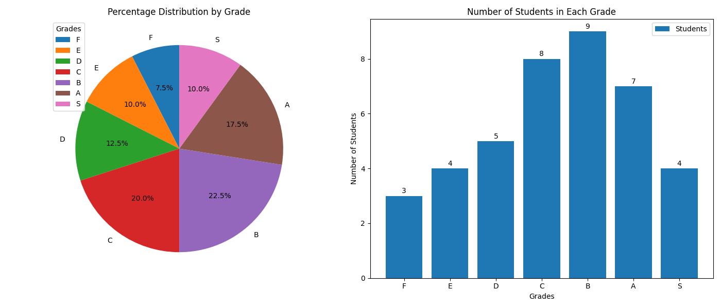
print("A and S combined percentage:", round(percentage, 2), "%")

